AVR Micro Controller

The AVR is a modified Harvard architecture 8-bit RISC single chip microcontroller which was developed by Atmel in 1996. The AVR was one of the first microcontroller families to use on-chip flash memory for program storage, as opposed to One-Time Programmable ROM, EPROM, or EEPROM used by other microcontrollers at the time.
The AVR architecture was conceived by two students at the Norwegian Institute of Technology (NTH) Alf-Egil Bogen and Vegard Wollan.
The original AVR MCU was developed at a local ASIC house in Trondheim, Norway called Nordic VLSI at the time, now Nordic Semiconductor, where the two founders of Atmel Norway were working as students. It was known as a μRISC (Micro RISC) and was available as silicon IP/building block from Nordic VLSI. When the technology was sold to Atmel from Nordic VLSI, the internal architecture was further developed by Alf and Vegard at Atmel Norway, a subsidiary of Atmel founded by the two architects. The designers worked closely with compiler writers at IAR Systems to ensure that the instruction set provided for more efficient compilation of high-level languages. Atmel says that the name AVR is not an acronym and does not stand for anything in particular. The creators of the AVR give no definitive answer as to what the term "AVR" stands for.
Note that the use of "AVR" in this article generally refers to the 8-bit RISC line of Atmel AVR Microcontrollers.
Among the first of the AVR line was the AT90S8515, which in a 40-pin DIP package has the same pin out as an 8051 microcontroller, including the external multiplexed address and data bus. The polarity of the RESET line was opposite (8051's having an active-high RESET, while the AVR has an active-low RESET), but other than that, the pin out was identical.
- The AVR is a modified Harvard architecture machine with program and data stored in separate physical memory systems that appear in different address spaces, but having the ability to read data items from program memory using special instructions.

Basic families
AVRs are generally classified into five broad groups:
- tinyAVR — the ATtiny series
  - 0.5–8 kB program memory
  - 6–32-pin package
  - Limited peripheral set
- megaAVR — the ATmega series
  - 4–256 kB program memory
  - 28–100-pin package
  - Extended instruction set (Multiply instructions and instructions for handling larger program memories)
  - Extensive peripheral set
- XMEGA — the ATxmega series
  - 16–384 kB program memory
  - 44–64–100-pin package (A4, A3, A1)
  - Extended performance features, such as DMA, "Event System", and cryptography support.
  - Extensive peripheral set with DACs
- Application specific AVR
  - megaAVRs with special features not found on the other members of the AVR family, such as LCD controller, USB controller, advanced PWM, CAN etc.
- FPSLIC™ (AVR with FPGA)

Features of ATMEGA8:

  - High-performance, Low-power Atmel®AVR® 8-bit Microcontroller
- Advanced RISC Architecture
  - 130 Powerful Instructions – Most Single-clock Cycle Execution
  - 32 × 8 General Purpose Working Registers
  - Fully Static Operation
  - Up to 16 MIPS Throughput at 16MHz
  - On-chip 2-cycle Multiplier
  - High Endurance Non-volatile Memory segments
  - 8Kbytes of In-System Self-programmable Flash program memory
  - 512Bytes EEPROM
  - 1Kbyte Internal SRAM
  - Write/Erase Cycles: 10,000 Flash/100,000 EEPROM
  - Data retention: 20 years at 85°C/100 years at 25°C(1)
  - Optional Boot Code Section with Independent Lock Bits
- In-System Programming by On-chip Boot Program
- True Read-While-Write Operation
  - Programming Lock for Software Security
  - Peripheral Features
  - Two 8-bit Timer/Counters with Separate Prescaler, one Compare Mode
  - One 16-bit Timer/Counter with Separate Prescaler, Compare Mode, and Capture mode.
  - Real Time Counter with Separate Oscillator
  - Three PWM Channels
  - 8-channel ADC in TQFP and QFN/MLF package
- Eight Channels 10-bit Accuracy
  - 6-channel ADC in PDIP package
- Six Channels 10-bit Accuracy
  - Byte-oriented Two-wire Serial Interface
  - Programmable Serial USART
  - Master/Slave SPI Serial Interface
  - Programmable Watchdog Timer with Separate On-chip Oscillator
  - On-chip Analog Comparator
  - Special Microcontroller Features
  - Power-on Reset and Programmable Brown-out Detection
  - Internal Calibrated RC Oscillator
  - External and Internal Interrupt Sources
  - Five Sleep Modes: Idle, ADC Noise Reduction, Power-save, Power-down, and standby.
  - I/O and Packages
  - 23 Programmable I/O Lines
  - 28-lead PDIP, 32-lead TQFP, and 32-pad QFN/MLF
  - Operating Voltages
  - 2.7V - 5.5V (ATmega8L)
  - 4.5V - 5.5V (ATmega8)
  - Speed Grades
  - 0 - 8MHz (ATmega8L)
  - 0 - 16MHz (ATmega8)
  - Power Consumption at 4Mhz, 3V, 25°C
  - Active: 3.6mA
  - Idle Mode: 1.0mA
  - Power-down Mode: 0.5Μa
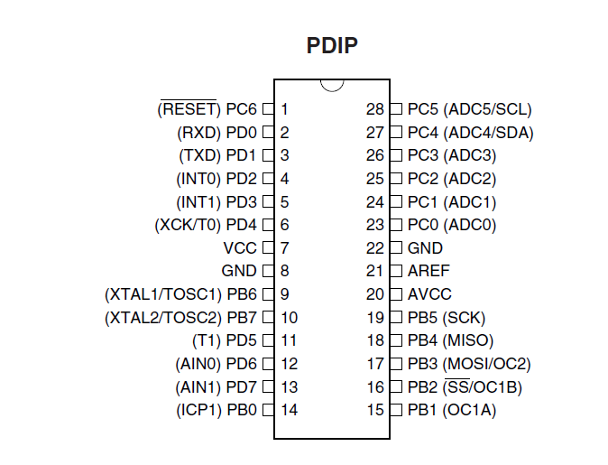
PinConfigurations: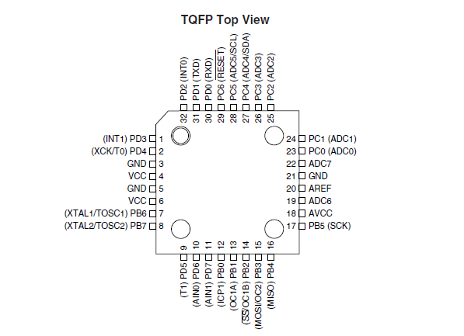
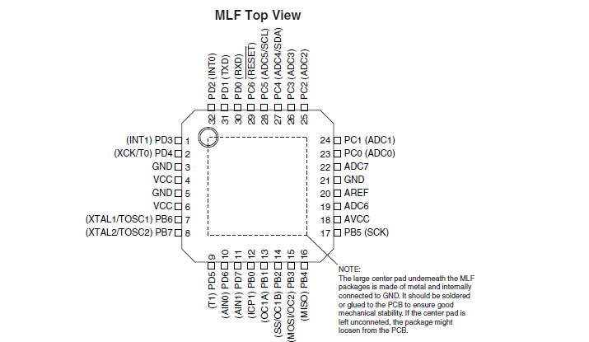

Overview:

The ATmega8 is a low-power CMOS 8-bit microcontroller based on the AVR RISC architecture. By executing powerful instructions in a single clock cycle, the ATmega8 achieves throughputs approaching 1 MIPS per MHz, allowing the system designer to optimize power consumption versus processing speed.
Block Diagram:

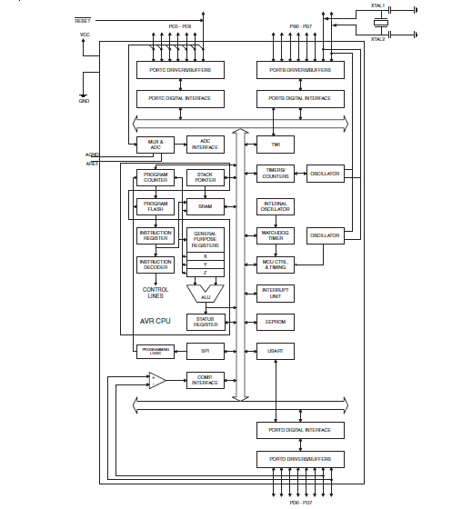

The AVR core combines a rich instruction set with 32 general purpose working registers. All the 32 registers are directly connected to the Arithmetic Logic Unit (ALU), allowing two independent registers to be accessed in one single instruction executed in one clock cycle. The resulting architecture is more code efficient while achieving throughputs up to ten times faster than conventional CISC microcontrollers. The ATmega8 provides the following features: 8 Kbytes of In-System Programmable Flash with Read-While-Write capabilities, 512 bytes of EEPROM, 1 Kbyte of SRAM, 23 general purpose I/O lines, 32 general purpose working registers, three flexible Timer/Counters with compare modes, internal and external interrupts, a serial programmable USART, a byte oriented Twowire Serial Interface, a 6-channel ADC (eight channels in TQFP and QFN/MLF packages) with 10-bit accuracy, a programmable Watchdog Timer with Internal Oscillator, an SPI serial port, and five software selectable power saving modes. The Idle mode stops the CPU while allowing the SRAM, Timer/Counters, SPI port, and interrupt system to continue functioning. The Powerdown mode saves the register contents but freezes the Oscillator, disabling all other chip functions until the next Interrupt or Hardware Reset. In Power-save mode, the asynchronous timer continues to run, allowing the user to maintain a timer base while the rest of the device is sleeping. The ADC Noise Reduction mode stops the CPU and all I/O modules except asynchronous timer and ADC, to minimize switching noise during ADC conversions. In Standby mode, the crystal/resonator Oscillator is running while the rest of the device is sleeping. This allows very fast start-up combined with low-power consumption. The device is manufactured using Atmel’s high density non-volatile memory technology. The Flash Program memory can be reprogrammed In-System through an SPI serial interface, by a conventional non-volatile memory programmer, or by an On-chip boot program running on the AVR core. The boot program can use any interface to download the application program in the Application Flash memory. Software in the Boot Flash Section will continue to run while the Application Flash Section is updated, providing true Read-While-Write operation. By combining an 8-bit RISC CPU with In-System Self-Programmable Flash on a monolithic chip, the Atmel ATmega8 is a powerful microcontroller that provides a highly-flexible and cost-effective solution to many embedded control applications. The ATmega8 AVR is supported with a full suite of program and system development tools, including C compilers, macro assemblers, program debugger/simulators, In-Circuit Emulators,

Pin Descriptions:
VCC Digital supply voltage.
GND:
Ground.
Port B (PB7..PB0) XTAL1/XTAL2/TOSC1/ TOSC2:

Port B is an 8-bit bi-directional I/O port with internal pull-up resistors (selected for each bit). The Port B output buffers have symmetrical drive characteristics with both high sink and source capability. As inputs, Port B pins that are externally pulled low will source current if the pull-up resistors are activated. The Port B pins are tri-stated when a reset condition becomes active, even if the clock is not running. Depending on the clock selection fuse settings, PB6 can be used as input to the inverting Oscillator amplifier and input to the internal clock operating circuit. Depending on the clock selection fuse settings, PB7 can be used as output from the inverting Oscillator amplifier. If the Internal Calibrated RC Oscillator is used as chip clock source, PB7..6 is used as TOSC2..1 input for the Asynchronous Timer/Counter2 if the AS2 bit in ASSR is set. The various special features of Port B are elaborated in “Alternate Functions of Port B” on page 58 and “System Clock and Clock Options” on page 25.
Port C (PC5..PC0):

Port C is an 7-bit bi-directional I/O port with internal pull-up resistors (selected for each bit). The Port C output buffers have symmetrical drive characteristics with both high sink and source capability. As inputs, Port C pins that are externally pulled low will source current if the pull-up resistors are activated. The Port C pins are tri-stated when a reset condition becomes active, even if the clock is not running.
PC6/RESET:

If the RSTDISBL Fuse is programmed, PC6 is used as an I/O pin. Note that the electrical characteristics of PC6 differ from those of the other pins of Port C. If the RSTDISBL Fuse is unprogrammed, PC6 is used as a Reset input. A low level on this pin for longer than the minimum pulse length will generate a Reset, even if the clock is not running. The minimum pulse length is given in Shorter pulses are not guaranteed to generate a Reset. The various special features of Port C are elaborated
Port D (PD7..PD0):
Port D is an 8-bit bi-directional I/O port with internal pull-up resistors (selected for each bit). The Port D output buffers have symmetrical drive characteristics with both high sink and source capability. As inputs, Port D pins that are externally pulled low will source current if the pull-up resistors are activated. The Port D pins are tri-stated when a reset condition becomes active, even if the clock is not running. Port D also serves the functions of various special features of the ATmega8 as listed on

RESET:

Reset input. A low level on this pin for longer than the minimum pulse length will generate a reset, even if the clock is not running. The minimum pulse length is given in Shorter pulses are not guaranteed to generate a reset.

AVCC:

AVCC is the supply voltage pin for the A/D Converter, Port C (3..0), and ADC (7..6). It should be externally connected to VCC, even if the ADC is not used. If the ADC is used, it should be connected to VCC through a low-pass filter. Note that Port C (5..4) use digital supply voltage, VCC.
AREF:

AREF is the analog reference pin for the A/D Converter.

ADC7.6 (TQFP and QFN/MLF Package Only):

In the TQFP and QFN/MLF package, ADC7..6 serve as analog inputs to the A/D converter. These pins are powered from the analog supply and serve as 10-bit ADC channels.

